Mobile Trash Collection Robot

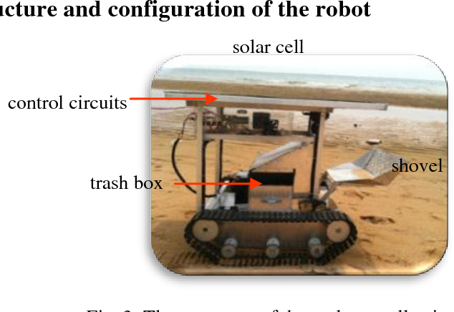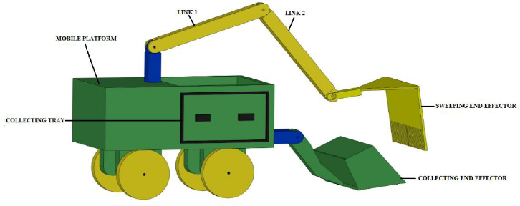

Core Functionality:
- Movement and Navigation: The robot will move around the area to find trash.
- Trash Detection: Using sensors, the robot detects the presence of trash.
- Trash Collection: Once the trash is detected, the robot either scoops it up, drops it into a collection bin, or pushes it into a designated area.

Key Components for the Mobile Trash Collection Robot

1. Arduino Board
- The Arduino will be the brain of the robot, controlling the motors, sensors, and decision-making logic.

2. Motors & Wheels
- DC Motors with Wheels: These will be used to drive the robot around. Depending on your design, you can have two wheels driven by DC motors (for differential drive) and one caster wheel for stability.
- Motor Driver: To control the DC motors, a motor driver (e.g., L298N or L293D) is necessary to interface the Arduino with the motors.

3. Sensors for Trash Detection
- Ultrasonic Sensors: These can help the robot detect obstacles (like trash or walls) in its path. The ultrasonic sensors will allow the robot to measure the distance to objects in front of it and avoid collisions while collecting trash.
- IR Sensors or Camera: While the ultrasonic sensors help with basic object detection, IR sensors or even a simple camera system (with image processing) could be used to detect trash on the ground, depending on your level of complexity. For a more advanced version, you could use a color sensor to detect objects with specific colors (like trash bags or cans).
- Proximity Sensors: These could be placed at the front or sides of the robot to help it detect objects directly in front of it.

4. Trash Collection Mechanism
- Container or Bin: The robot will need a container or bin to collect the trash. This can be a simple box or bucket that the robot carries or drags behind it.
- Scooping Mechanism (optional): If you want to have the robot physically scoop or push trash into its bin, you could implement a simple mechanical scooping arm, or a rotating brush that pushes trash into the bin. This would be controlled by servo motors or DC motors to operate the scooping action.

5. Power Supply
- The robot will need an appropriate battery pack (e.g., 12V or 7.4V Li-ion battery) to power the motors, Arduino, and sensors.
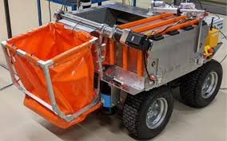

How It Works: Mobile Trash Collecting Robot
Here’s a breakdown of how the trash collecting robot could operate:
- Movement and Navigation:
  - The robot will navigate the space using its DC motors. It could use a simple line-following system (with infrared sensors) or rely on ultrasonic sensors to detect obstacles and avoid them as it moves.
  - The robot can be programmed to follow a set pattern, like moving in a zig-zag or grid-like motion to cover the area. Alternatively, it could be programmed with more advanced algorithms (like SLAM — Simultaneous Localization and Mapping) to map out its surroundings and navigate autonomously.
- Trash Detection:
  - As the robot moves, it continuously checks for the presence of trash using its ultrasonic sensor or IR sensors.
  - Once the robot detects trash (based on proximity or visual cues from the IR or camera sensors), it stops, gets closer to the trash, and prepares to collect it.
- Trash Collection:
  - The robot will either push the trash into its collection bin or scoop it if it has a dedicated mechanism. A simple option would be to have the robot stop, use a brush or scoop arm, and move the trash into a designated container or bin attached to the robot.
  - If using a brush mechanism, a rotating brush could push trash into the robot's collection area. Alternatively, if you use a scoop mechanism, the robot would lower a scoop or arm, grab the trash, and lift it into the bin.

